<Self Introduction/>

|  |  |
| --- | --- |
| Name | Arshdeep Singh |
| ID | #133462176 |
| Email | asingh568@myseneca.ca |
| Program | Honours Bachelor of Technology  - Software Development (BSD) |

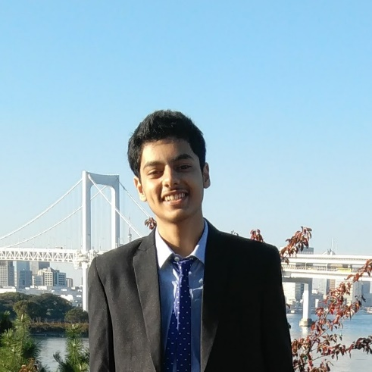

# **Interests/Hobbies**

* Programming
* Reading about technology

# **Skills**

* Programming
* Graphic design

# **Career aspiration**

* To become a software developer and contribute to open source